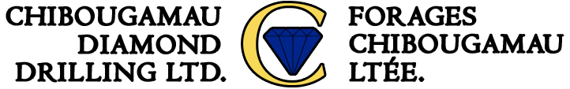

INVITATION TO BID

Please complete the field below.

INFORMATION ON SENDER
From :

E-mail :
End date :

INFORMATION ON BID
Maximum footage : |  | Minimum footage :
Starting date : |  | End date :
Location :  Please attach map if possible |  | Other specifications :
Access to location:  Ex : All-weather / winter road / by aircraft only |  | Other specifications :

(Next page)

CORE DRILLING
Size :  (NQ/BQ/HQ/PQ) |  | Angle :
Maximum depth : |  | Minimum depth:
Rock type(s):

OVERBURDEN DRILLING
Overburden type :
(Sand, dirt, gravel)

Maximum depth : |  | Minimum depth:
Need casing cap : |  | Casing left in holes :

MOVING CONDITIONS
Number of holes : |  | Maximum distance between holes :
Topography :  Flat area / moderate relief / rugged |  | Road conditions :  Clear / swamp / light bush / heavy bush

GENERAL CONDITIONS
Maximum lift : |  | Maximum length :
Waterline : |  | Board required for :
Company camp : |  | Company representatives :
Contractor’s camp :

(Next page)

CONTRACTOR TO SUPPLY
Core boxes : |  | Quantity :
Hydraulic core splitter :  : |  | Nombre de lames :
Core orientation instrument : |  | Deviation type :
Deviation instrument :

All information above is correct : a

Contractor’s signature : ______________________________ Date : ___________________________

